### Project Name: Job Application Tracking System - (Developer)

### Team ID : LTVIP2024TMID11609

### Team Leader : S MOHAN

### Team member : N PUNEETH KUMAR

### Fields And Relationship

**Creation Of Fields For The Recruiter Objects**

1. click the gear icon and select Setup. This launches Setup in a new tab.
2. Click the Object Manager tab next to Home.
3. Select Recruiter.
4. Select Fields & Relationships from the left navigation, and click New

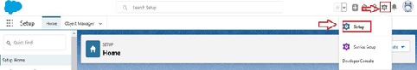  
  
  
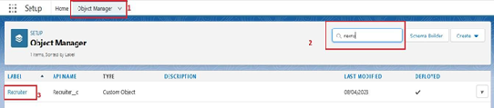  
From the sidebar, click Fields & Relationships. Notice that there are already some fields there. Those are the standard fields.  
  
  
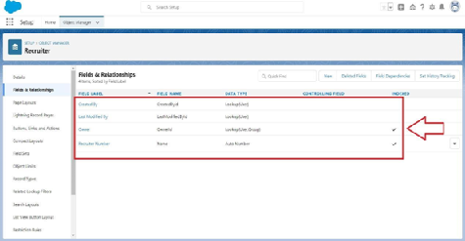  
  
  
Click New to create a custom field. Tip: Before creating a new field, do a quick search to make sure a similar one doesn’t already exist.  
  
  
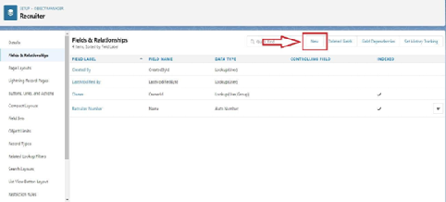  
5.Choose the data type as Auto number, click next  
  
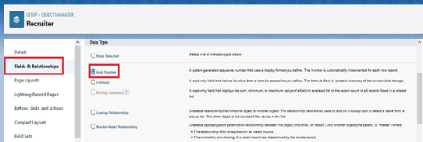  
  
6.Enter field label(Recruiter Number), Display formate RN-{0000} Starting number(1) and click next  
  
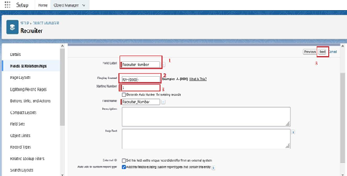  
7.Next,Next and Click save.  
  
Now let's create the other fields follow above Activity1 steps 1 to 4 and we must choose the data types of the fields carefully  
 Select the Text as the Data Type, then click Next. For Field Label, Job Title. Enter Length (20) Click Next, Next, then Save & New.

1. Select the Email as the Data Type, then click Next. For Field Label, Email.
2. Click Next, Next, then Save & New.
3. Select the phone as the Data Type, then click Next. For Field Label, Phone.
4. Click Next, Next, then Save & New.

### Creation Of Fields For The Job Objects

**Follow the above steps from 1 to 4 of activity 1**  
1.Select the Auto number as the Data Type, then click Next.

For Field Label, enter Job Application Id., Display format (J-{000}) starting number (001) Click Next, Next, then Save & New  
  
2.Select the Text area as the Data Type, then click Next. For Field Label, Description.

Click Next, Next, then Save & New.

3.Select the **Text** as the Data Type, then click Next. For Field Label, enter Location, and length (20) Click Next, Next, then Save & New

**Creation Of Master-Detail Relationship For Job Object**

1.From Setup, go to Object Manager  
2.On the sidebar, click Fields & Relationships.  
3.Click New.  
  
  
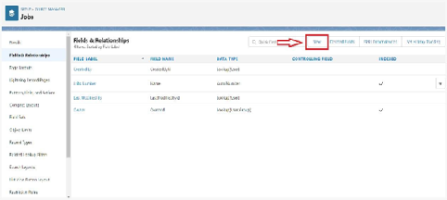  
  
4.Choose Master-detail Relationship and click Next

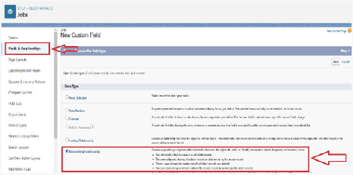

5.Choose the related object(Recruiter) and select that object.

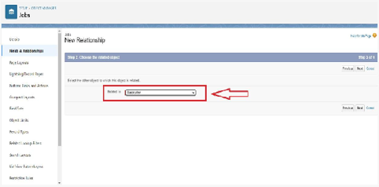  
  
6.Enter the label name(Recruiter Name)  
  
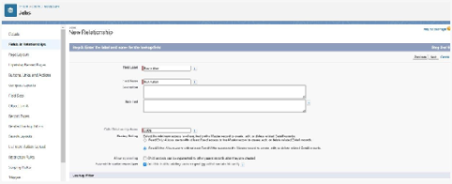  
7.Click Next, Next, and Save

**Creation Of Fields For The Candidate Object**

Follow the above steps from 1 to 4 of activity 1  
1.Select the Text area as the Data Type, then click Next. For Field Label, Address,  
Click Next, Next, then Save & New.  
2.Select the Email as the Data Type, then click Next. For Field Label, enter Email.  
Click Next, Next, then Save & New.  
3.Select the Phone as the Data Type, then click Next. For Field Label, enter Phone.  
Click Next, Next, then Save & New  
4.Select Picklist as the Data Type and click Next. For Field Label enter Education.  
Select Enter values, with each value separated by a new line and enter these values: Graduation ,  
Post-Graduation. Click Next, Next, then Save & New.  
5.Select the Text area as the Data Type, then click Next. For Field Label, enter Skill Set.   
Click Next, Next, then Save & New

**Create Picklist Fields On Candidate Object**

* Click on the gear icon and then select Setup.
* Click on the object manager tab just beside the home tab.
* After the above steps, Select candidate Object
* Now Select Fields and relationships from setup menu of the candidate object.
* Click new and select Picklist fields ????next and enter label name(State) and select enter values option

                               (Rajasthan, UP, MP, Punjab), next, next and Save.

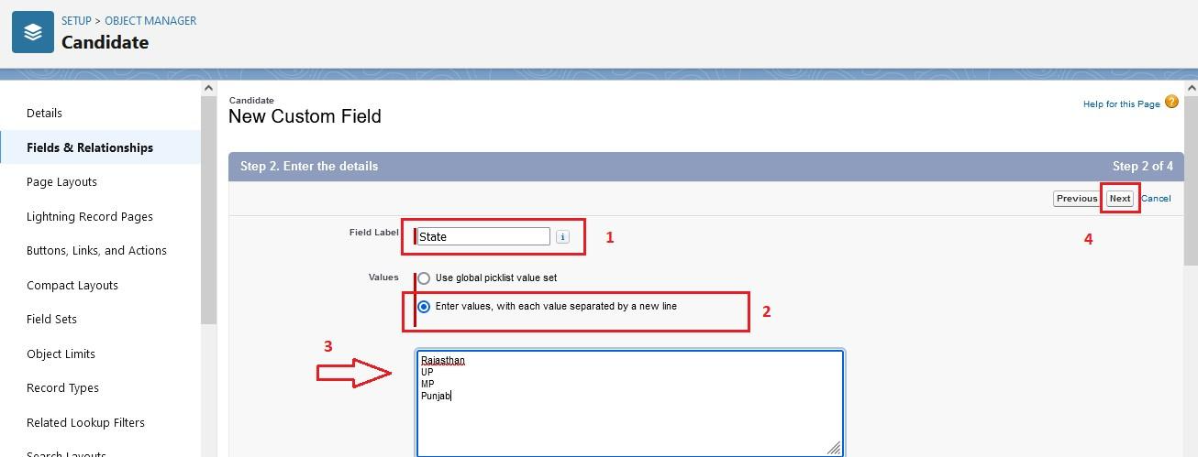  
  
Follow same above steps for create city and Education Picklist fields with their values.  
1.Select Picklist as the Data Type and click Next. For Field Label name City

  And Select Enter values, with each value separated by a new line and enter these values  
                                       (Jaipur, Jalandhar, Lucknow, Bhopal), next, next and Save.  
2.Select Picklist as the Data Type and click Next. For Field Label enter Education.  
    Select Enter values, with each value separated by a new line and enter these values: Graduation ,  
    Post-Graduation. Click Next, Next, then Save & New

**Create Field Dependency (On Candidate Object)**

Create a dependency between these two picklists, so that when a state is selected, only respective Values are available.  
The below steps will assist you in creating Field Dependencies.

* Click on the gear icon and then select Setup.
* Click on the object manager tab just beside the home tab.
* After the above steps, Select Candidate Object
* Now Select Fields and relationships from setup menu of the Candidate object.
* Click Field Dependencies.
* Click New.
* Select State as the Controlling Field and select City as the Dependent Field.
* Click Continue.
* Select the appropriate Value in each column by double-clicking them.
* For Ex. Rajasthan - Jaipur
* Click Include Values. And it is also same for UP, MP& Punjab with its city.
* Click Preview, then test the dependency by selecting different State and viewing the associate Values available for Particular state.
* Click Close to close the preview window.
* Click Save.

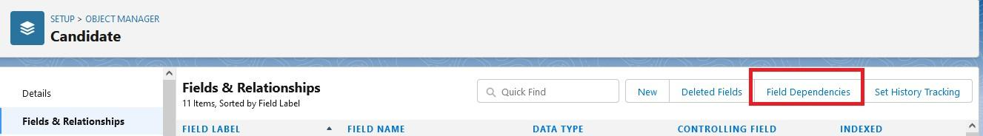  
  
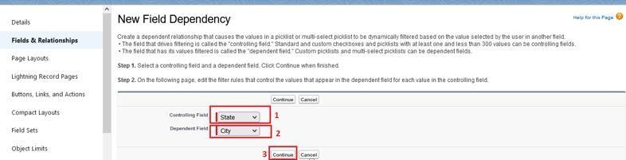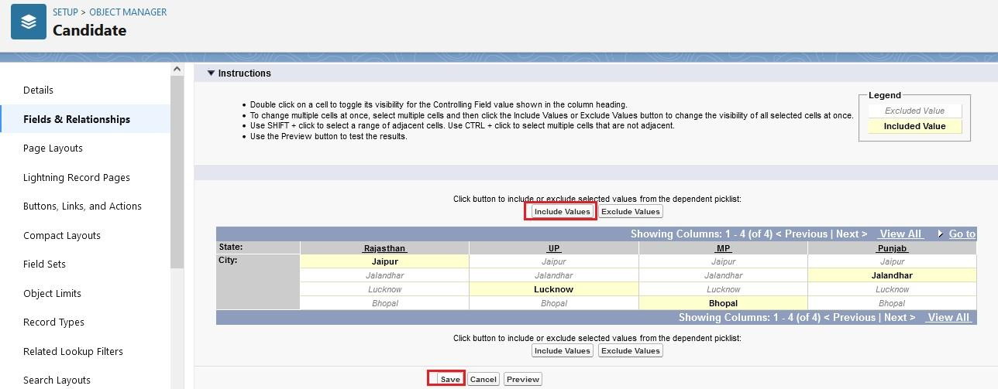

**Creation Lookup Relationship For The Job Application Objects**

**Let’s create two lookup relationship on job application object First lookup relationship**  
**From Setup, go to Object Manager**

* On the sidebar, click Fields & Relationships.
* Select Lookup relationship & click next
* Choose the related object as Candidate & click next
* Give the field label(Candidate name) & click next, next, next and Save

**Second lookup relationship**

* From Setup, go to Object Manager
* On the sidebar, click Fields & Relationships.
* Select Lookup relationship & click next
* Choose the related object as Job & click next
* Give the field label(Job Name) & click next, next, next and Save

### Profile

* **Create A Custom Profile**
* 1.From setup , enter profiles in Quick Find box  
  2.Select profiles (Standard user).  
  3.Click clone.  
  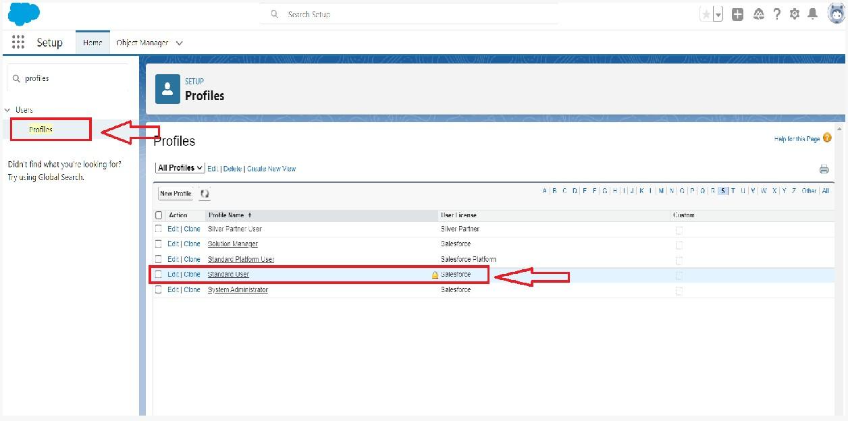
* 4.For Profile, enter Recruiter.  
    
  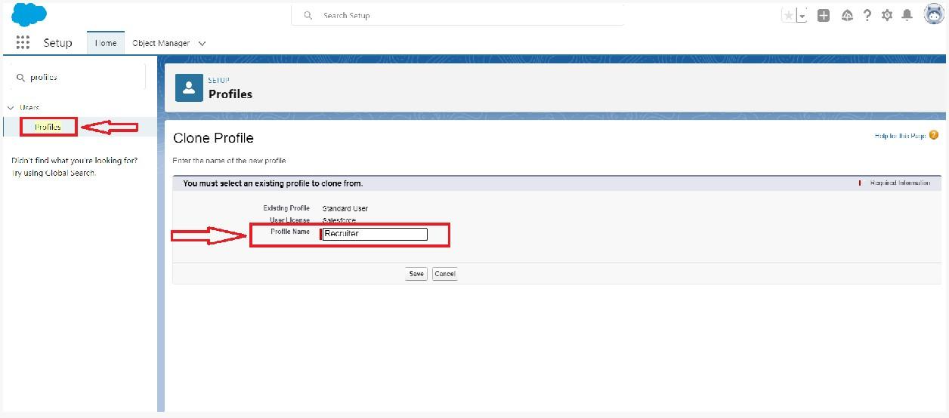  
  5.Click save.
* **Create A Custom Profile-2**
* Create a profile with the profile name as “Sales Manager”.   
    
  1.From setup , enter profiles in Quick Find box  
  2.Select profiles (Standard user).  
  3.Click clone.  
    
  Follow the steps from above Activity